Weobley High School

Celebration of curriculum excellence

We are extremely proud to present a newsletter bursting with examples of outstanding work produced by our students over the period of remote learning. Each subject has compiled a roll call of honour, and there are also examples of work by students who have excelled in terms of progress and/or effort. Congratulations everyone.

Art
The year 7 students did an Origami project called Paper Manipulation, responding to Natural Forms as a sculpture.
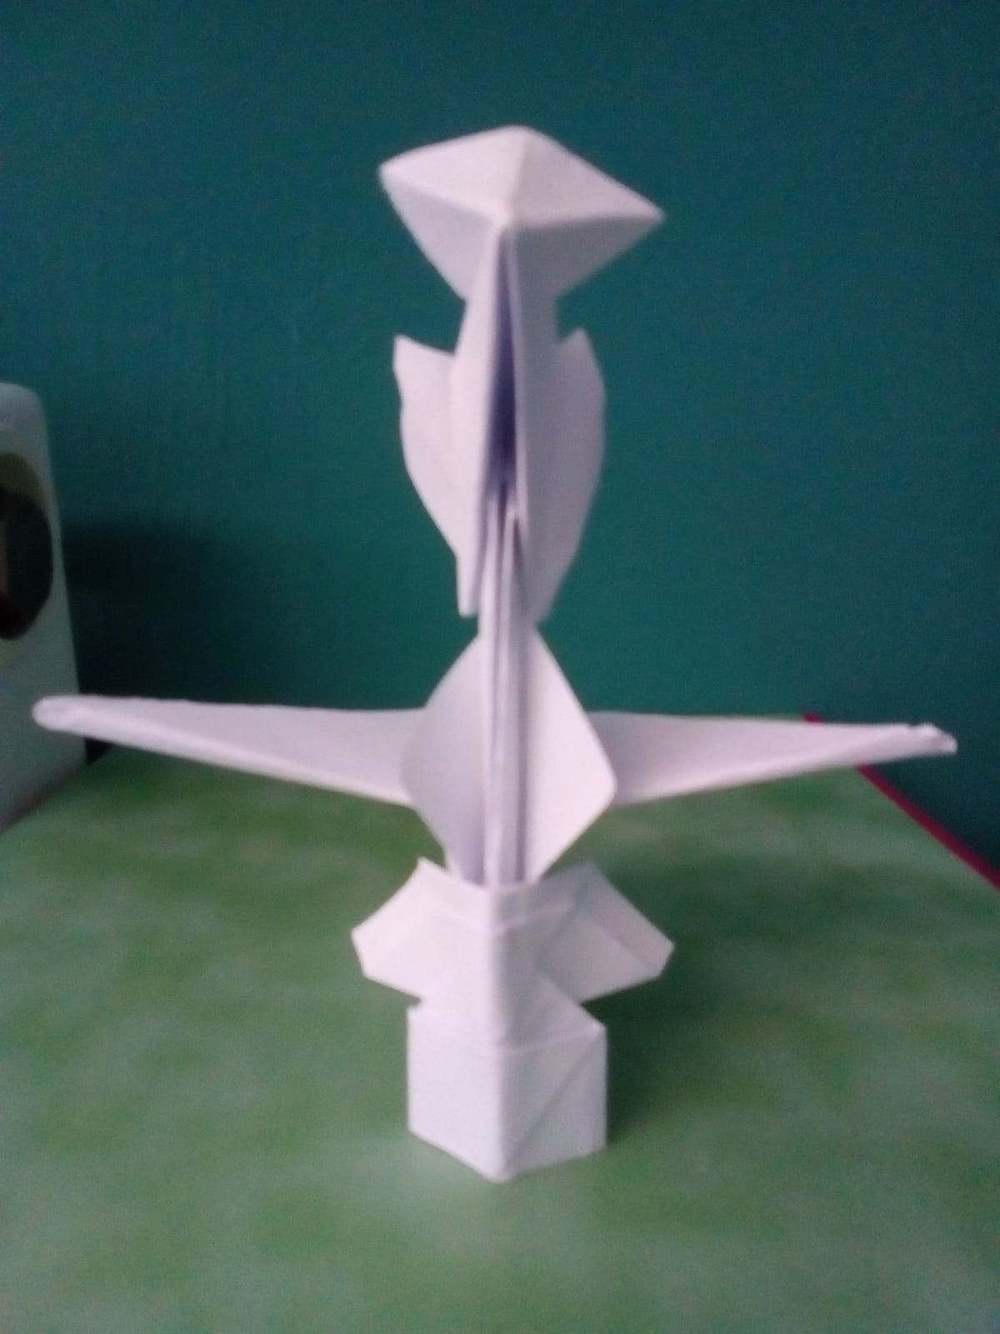
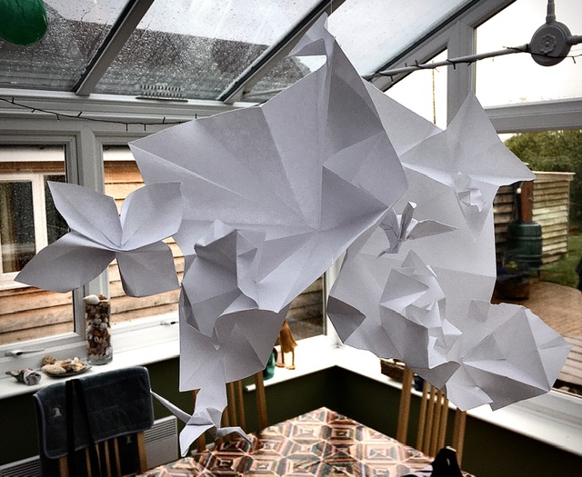

Esme Grice
Lilly Spinks

The year 8 students made cardboard Bas – Relief work, responding to Architectural Forms and details in their surrounding environment, through photography and then using cardboard to build the forms. They used different strengths of coffee to add tone and colour.
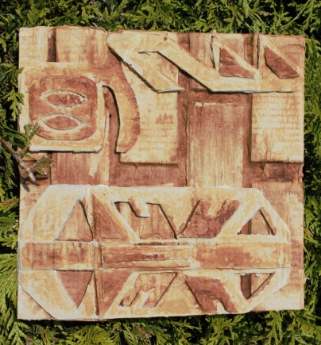

Yoshi Luffingham-Adams

Year 9 did a project on War and Conflict, looking at their family history and how their own families were involved in the war.
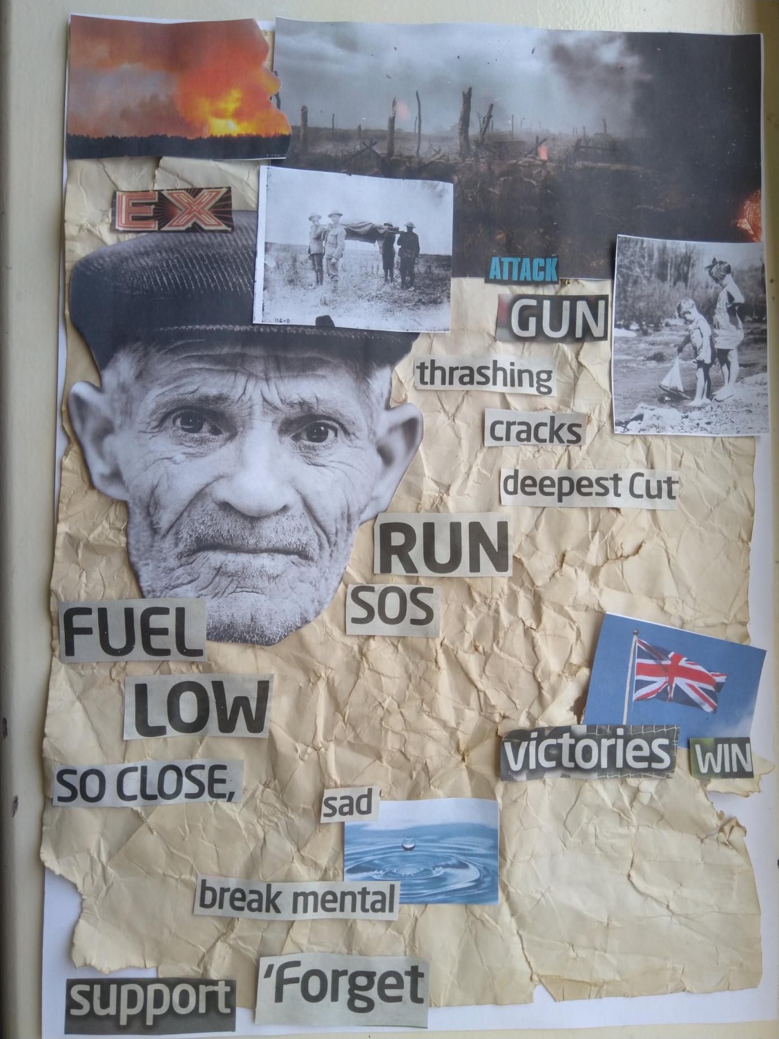
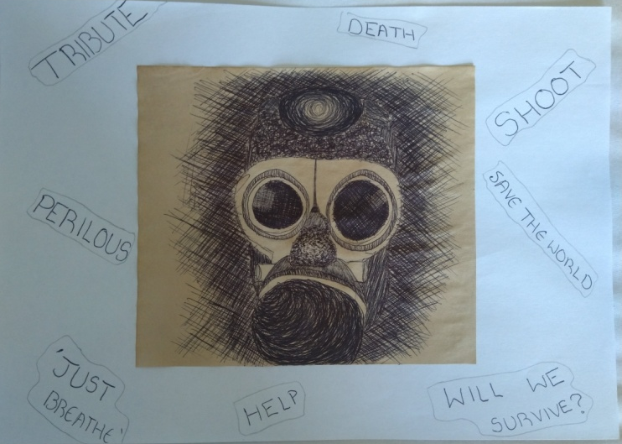

Jessica Prime
Jessica Prime
Year 9 also did some photography and drawing of trees and landscapes, responding to Artists’ techniques.
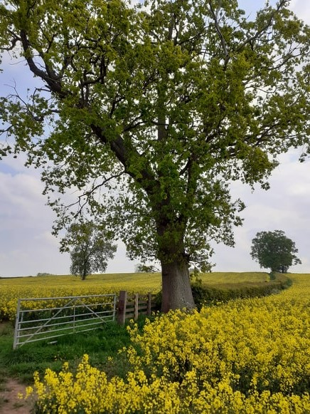
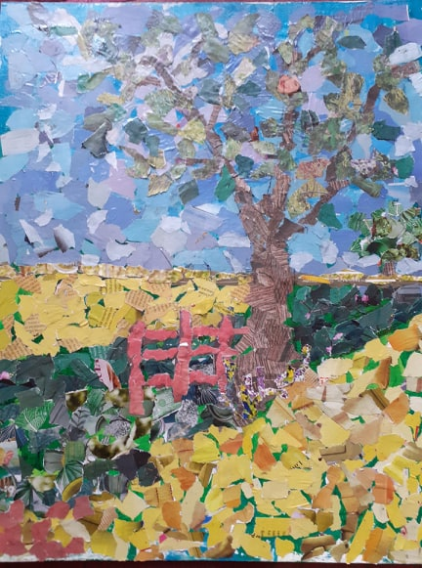
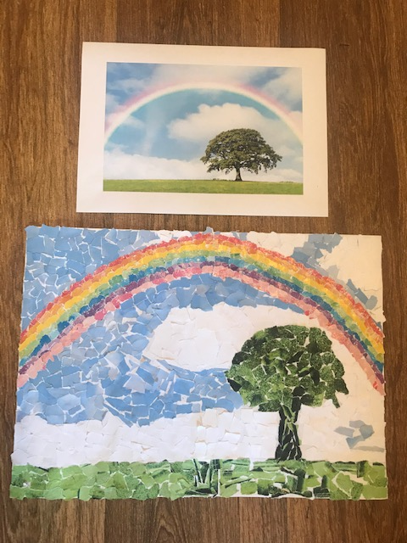

Drew Carter
Kyle Barton

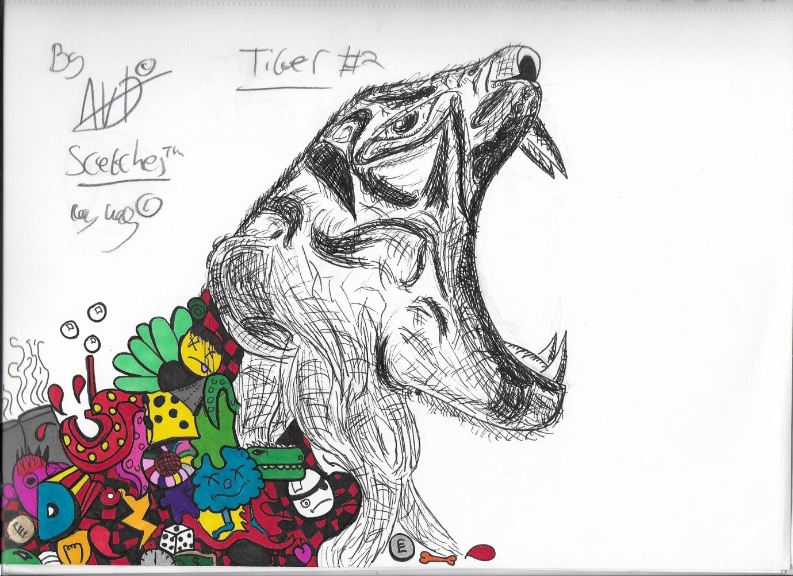

Independent art work by Davey Williams

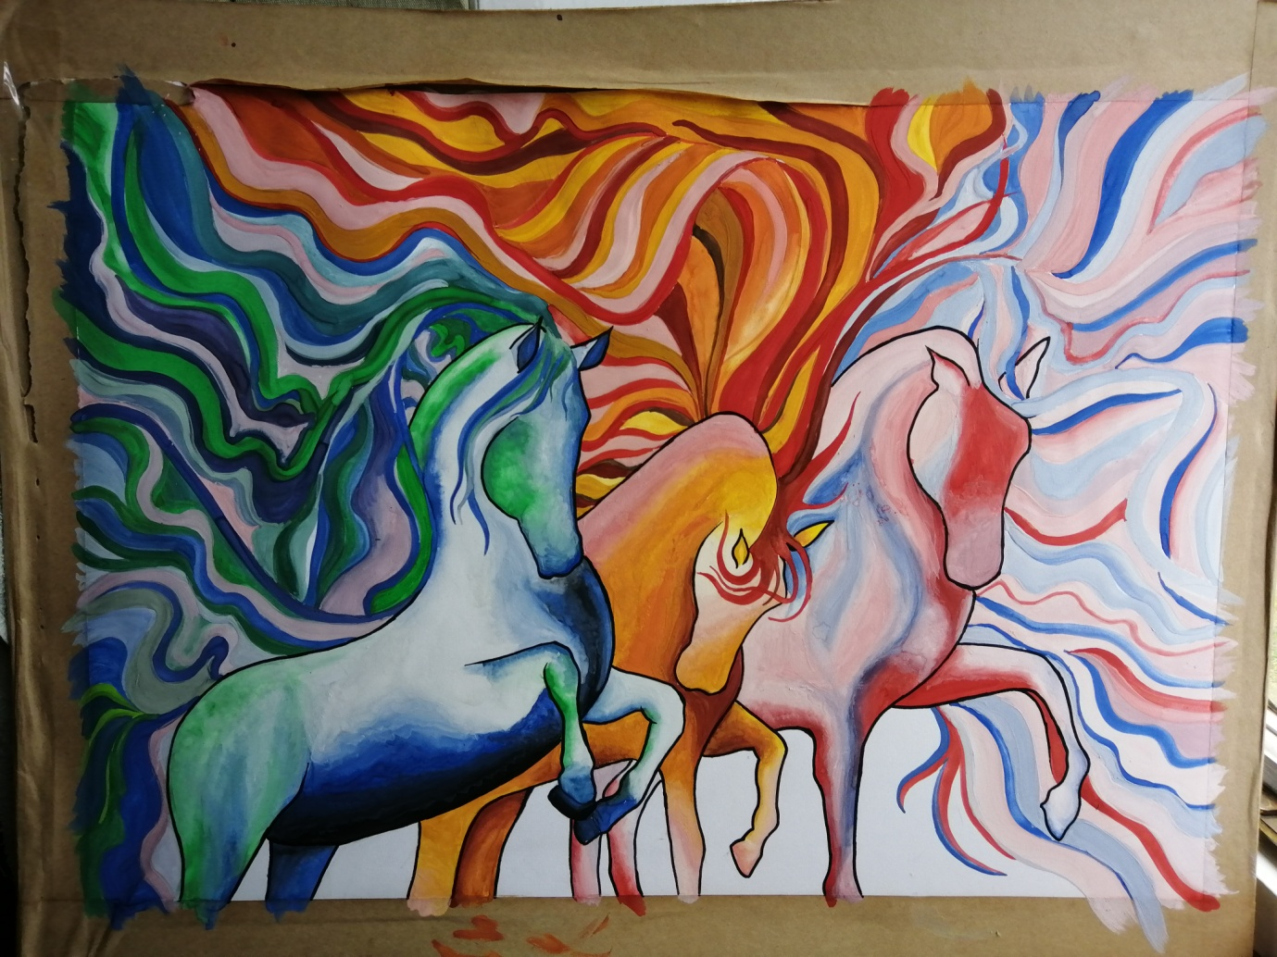
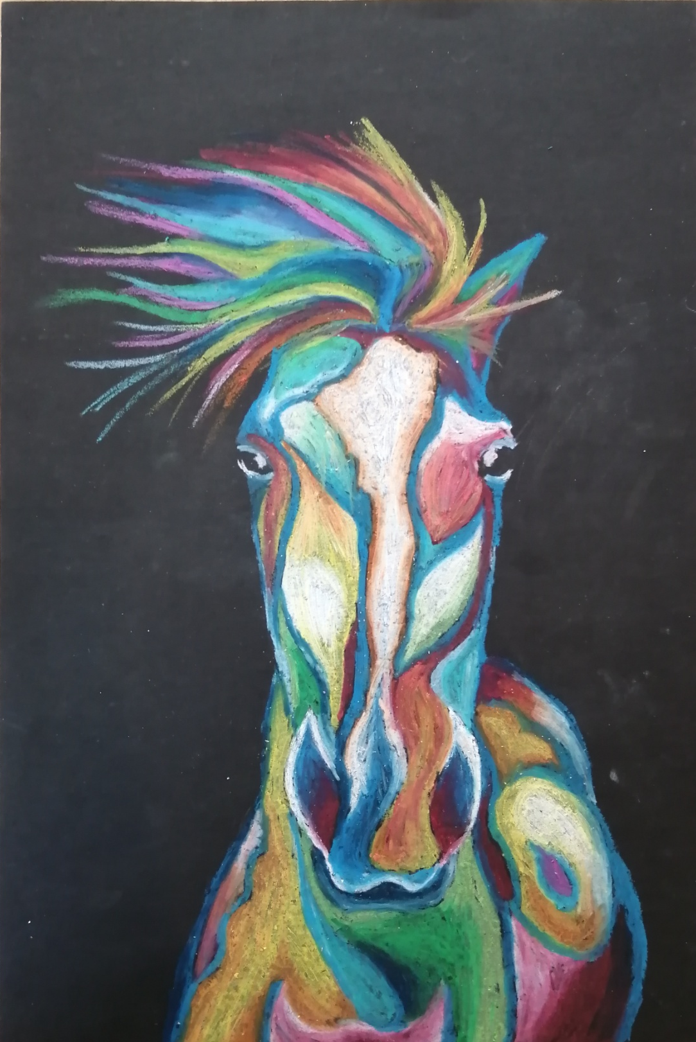
Year 11 are making a personal project for coursework. Lucy is observing horses, stylising them using colour and shape to highlight their form.
Lucy Hall
Lucy Hall

Drama
The class have been working on the Live Review component of their G.C.S.E examination and have recently watched a recording of the play A Monster Calls by Patrick Ness. Their task was to take the theme of fear and create their own interpretation of a fear monster using inspiration from the actual monster at The Old Vic Theatre production.
Making a monster
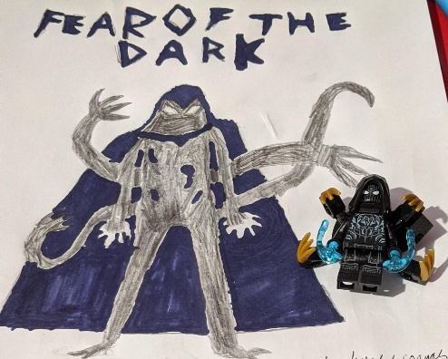
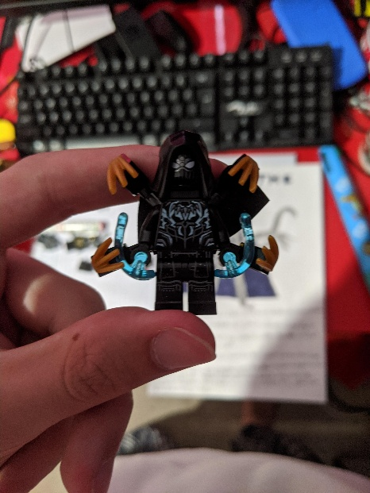
After thinking about lots of common fears, I chose to make a monster based on “fear of the dark” as I feel it is one of, if not, the most common fears that people have.

After that I decided to draw the monster to make some of its features more noticeable.
Next, I made some notes about its appearance and actions:
- Movement- slow and fluid. Crawls on all fours and looks as though it could lunge at you at any second.
- Attitude to the audience- may look at the audience and growl, as if it knows it’s being watched. May come out from the audience to scare them.
- Eye contact- never makes direct eye contact unless attacking, in which case it stares directly at the victim.
- Sounds- it doesn’t make sound, no matter what he’s moving on or through. Speaks in murmurs, growls, or hisses.

Then, as it had to have a weakness, I decide that it should freeze when light is shone onto it, for example a flashlight would cause it to freeze. However, it can cause the lights to malfunction and break. Oscar Jones

English – Creative writing
All students were asked to complete a weekly writing challenge. These included creating their own villain, re-writing a fairy tale from an alternative perspective, describing a lighthouse during a storm and writing their own murder mystery. Here are some excellent examples……

KS3
Eric opened his eyes to see that the colossal wave had frozen solid – the halted water licking the sky like enormous, blue flames. Esme Grice
As I licked my lips, the soft sound of singing broke the silence and her scent drifted towards me and up my nostrils filling me with an urgent desire to sprint out of that door and tear her to shreds, but I like to have fun with my prey, so, slipping under the duvet , I cleared my throat and waited. Waited for the fun to begin. Ashia Day

Stealthily creeping through the woods, I sensed her presence. Little red shoes crunched along the woodland path which ran through the heart of my domain. Tristan Harvey

The battle had begun – water balloons flew through the air like grenades. Everyone ducked, dodged, swerved out of the way. Oliver Murray

The colossal crashing waves surrounded the tower, like a cape of despair. The waves were parting as if Moses himself was walking towards the lighthouse. Ben Connolly

Giving gifts, preparing the Christmas dinner, decorating the house and tree together; these are the most amazing parts of Christmas. It makes us appreciate everything we have... and who doesn’t feel content, being able to look at a beaming smile on somebody’s face, as they open a gift from you? Jessica Prime

Dearest Delilah,
When I received your letter, saying that you were positive that there was a ghost inhabiting your attic I almost fell off my lounge chair with laughter. Of all people, you especially shouldn’t believe in the trivial stories that people make up. People will assume you are still a child although you are almost 14! You need to start acting like a lady not a foolish infant. I do desperately hope you haven’t started to believe the horror stories that all your friends prattle on about. You should be trying to find a husband and not a silly ghost in your attic. Caitlin Watters
Doubt. Worry. Fear.
He did not only know what those words meant; he had never known a life without them. To every thought that plagued his mind, conscious or not, it was accompanied with all or one of those emotions. He knew his insecurities better then he knew his family and his family were the only people he spoke to. They were his lifeline, his therapy, his lifeboat. Hannah Murdoch
The colossal waves slammed into the walls of the lighthouse. The boy clutched the rails of the ladder so hard his knuckles turned white. He stared down into the churning water below from his viewpoint on the top of the lighthouse. It fizzed and moved as though it was a malicious creature, full of hatred at this frail lighthouse quaking in its path. Lily Spinks

English
One day we will see the truth - that social media is to the brain what smoking is to the lungs. The toxic anxiety and the regular dosage of fear enhance our biological need to fit in. The need to fit in is associated with anxiety, in fact – it is a major reason why anxiety exists among youth. Social media exaggerates everything including the anxiety of its victims. And worse than that the owners of these enterprises profit from this exploitation. It is a cruel form of greed. Naomi Watters

KS4

The Don stood at the head of the table, cleaning off a long knife, like a motionless spider removing the remains of a fly from its web. Oscar Jones

Her wolfish grin, with teeth just a little too sharp to be human, haunts the minds of the few who survive glancing at her. The scent of sickly-sweet apples and pine cavorts in her wake. Lucy Bentham

In one hand, he held his metal cane which had been rumoured to hide his rapier. In the other, like clockwork, he spun the half-melted coin between his fingers, some sort of sick souvenir from the incident that had given him his distinctive footsteps. Step, clink. Step, clink. Oliver Grice

So, when the guards endlessly train, preparing for the battle they know will end in their bloodshed, it is not the enemy army of warriors they fear. When cacophonies of thunder fill the castle walls, it is not the thought of bandits that haunt their dreams. And when the king looks at his family over their magnificent feast, it is not worry of uprising that plagues his mind. No, it is the Silver Mist.
Molly Sherrard

A wicked grin stretched across his skeletal face as he watched the world progress around him. He convulsed suddenly, his body twisting like a puppet on a string. A torrent of low inaudible words shot out of his open mouth, scraping against the back of his throat, and catching in the stale air. Elyssa Hunter

In our modern and heavily insulated world, there are many restrictions and safety regulations that control and debilitate the natural freedom that teenagers crave.

I remember hearing stories my parents would tell of camping and walks where they enjoyed the world around them, freeing themselves from the clammy hands of social and emotional pressure that plague many of our transitioning citizens. Grace Murdoch

By isolating teenagers, and perpetuating this stigma that surrounds them, they will be branded as antisocial, violent thugs. What kind of message is this sending?

I, myself, am partial to the occasional mood swing. However, I am baffled by the sheer disregard and obliviousness exhibited here by people in authority. The teenage stereotype perpetuated by the media is just that, a stereotype.

This curfew is simply a tyrannical power grab built on the foundations of negative stereotyping. And it is one I refuse to accept. Leila Simner

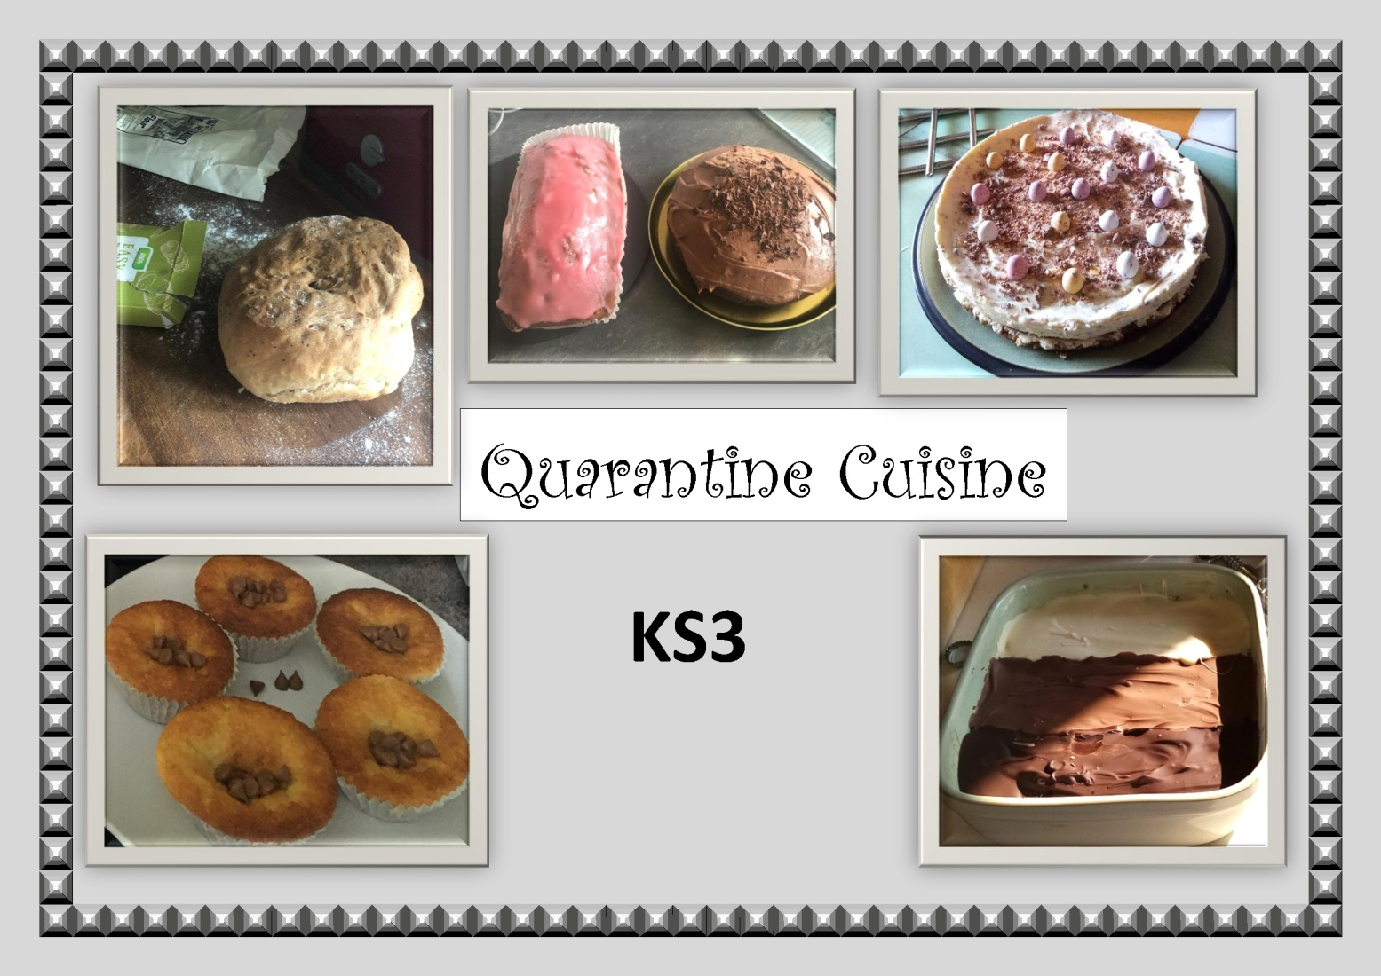
Food Technology
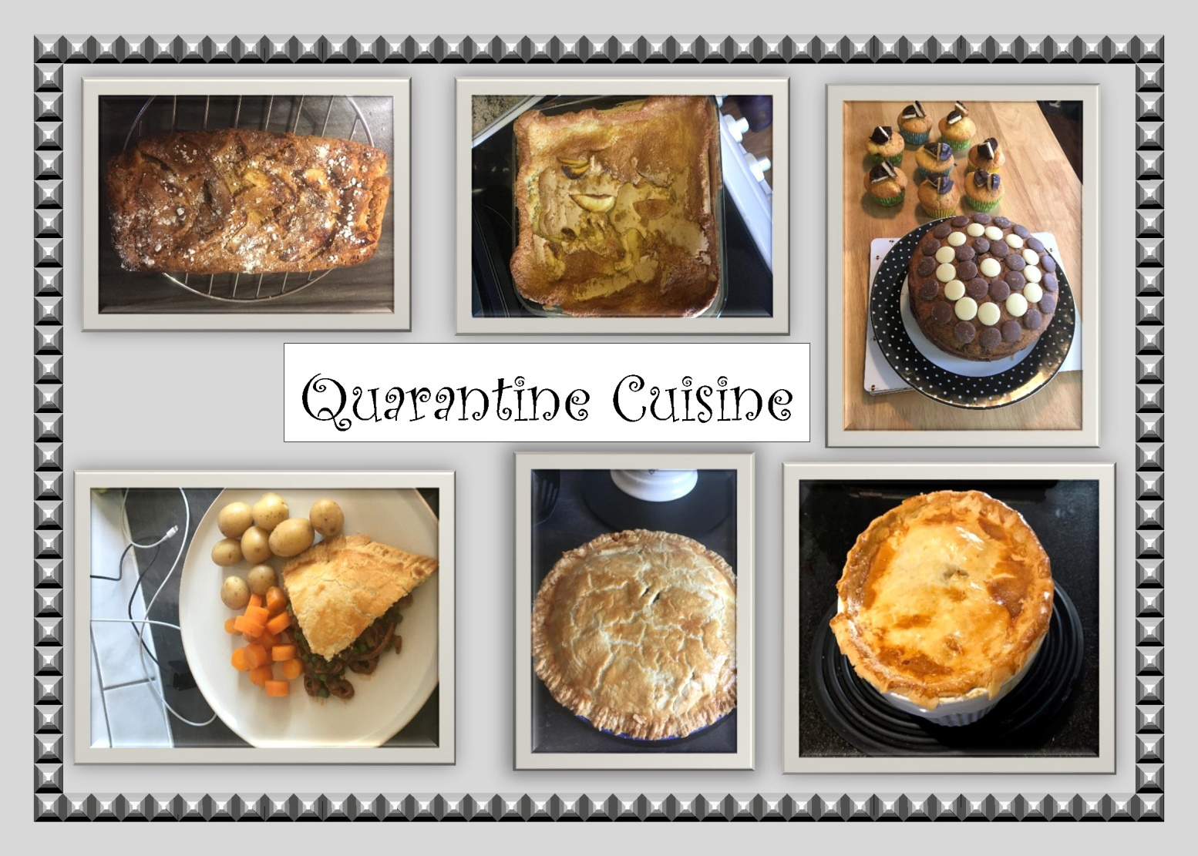

History
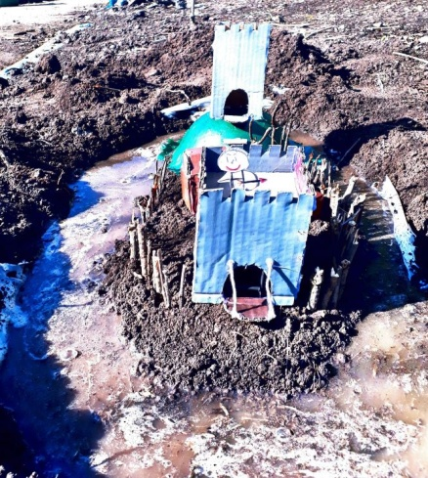
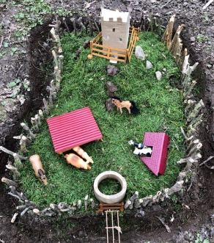
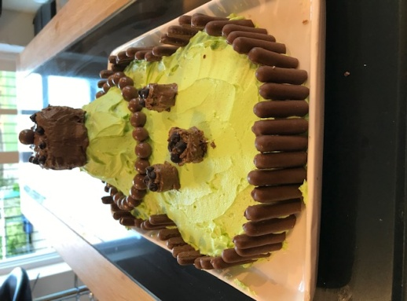
The History department have had a busy term of remote learning with year 7 building their own castles, year 8 considering Florence Nightingale’s place in our lives through poetry, celebrating V:E day and some students undertaking independent study of the Romans. Here are examples of their wonderful work:
Gabbi Price
Holly Bunston
Ellie Pilliner

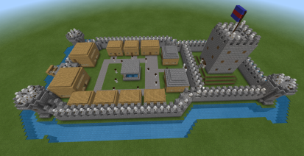
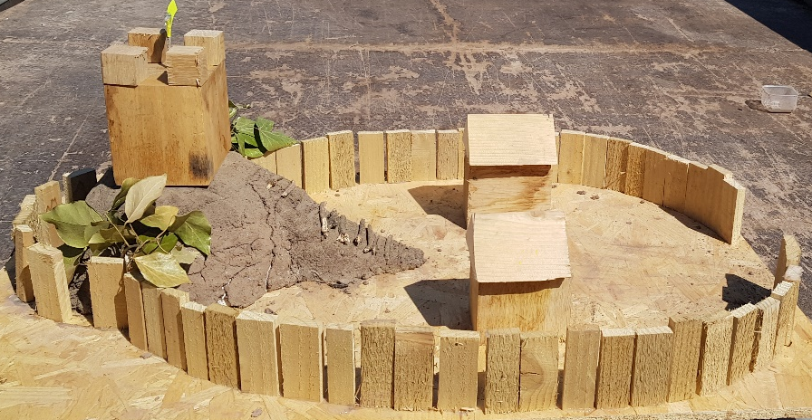
Dan Whittal
Charlie Palmer

Florence nightingale poem

Florence nightingale was a nurse
She volunteered and rehearsed
And to this day we all know is started in an army hospital a long time ago
Diseases in there was one of the reasons why the death rate was so high
She helped and cared for the army soldiers
Putting blankets on their shoulders
She was with the ill through every pain every cramp
And that’s why we remember her as the lady with the lamp

By Gabbi Price

Florence nightingale poem

Florence Nightingale loved to read
Florence Nightingale was determined to heed.
She grew up with her sister in a large country house
Her mother had a wealthy spouse.

Florence Nightingale was seventeen,
To make a difference, she found herself keen.
38 nurses she was to train,
Strictness and order she did engrain.

Off to Turkey to the Crimean war
Determination at her core.

Lucy-Jo Messer
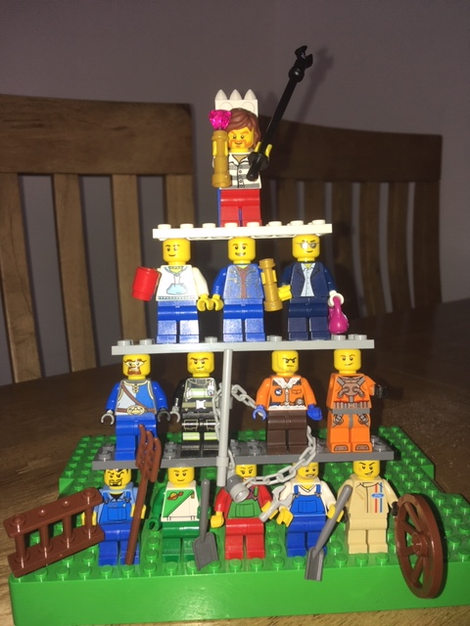
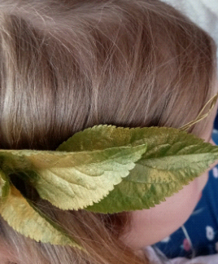
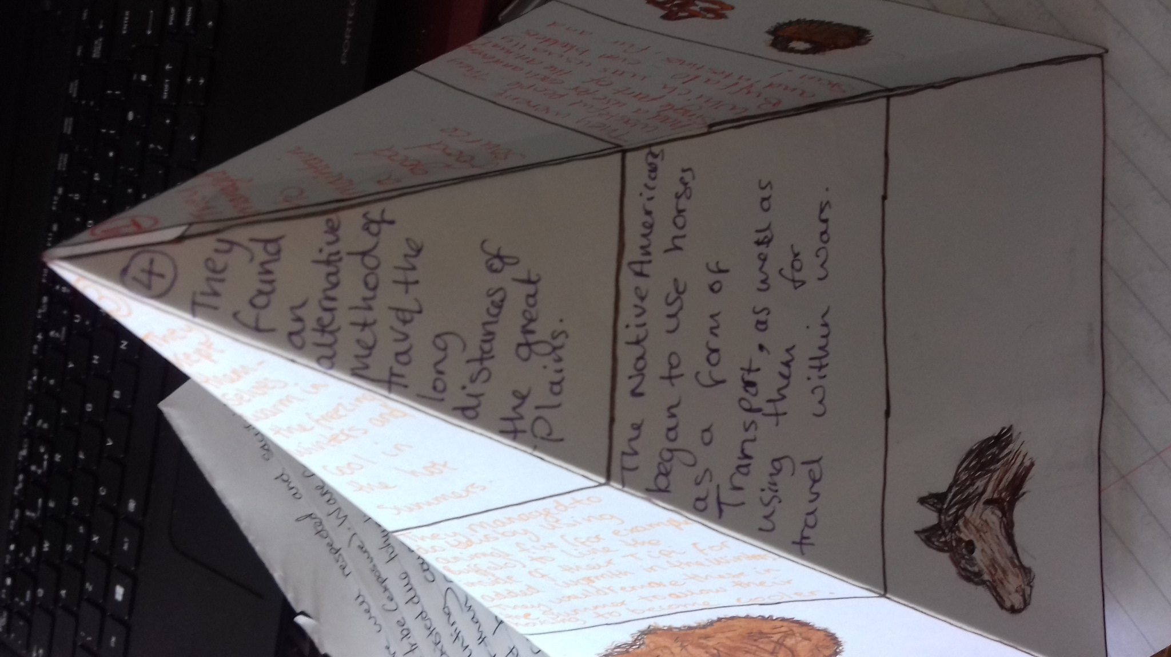
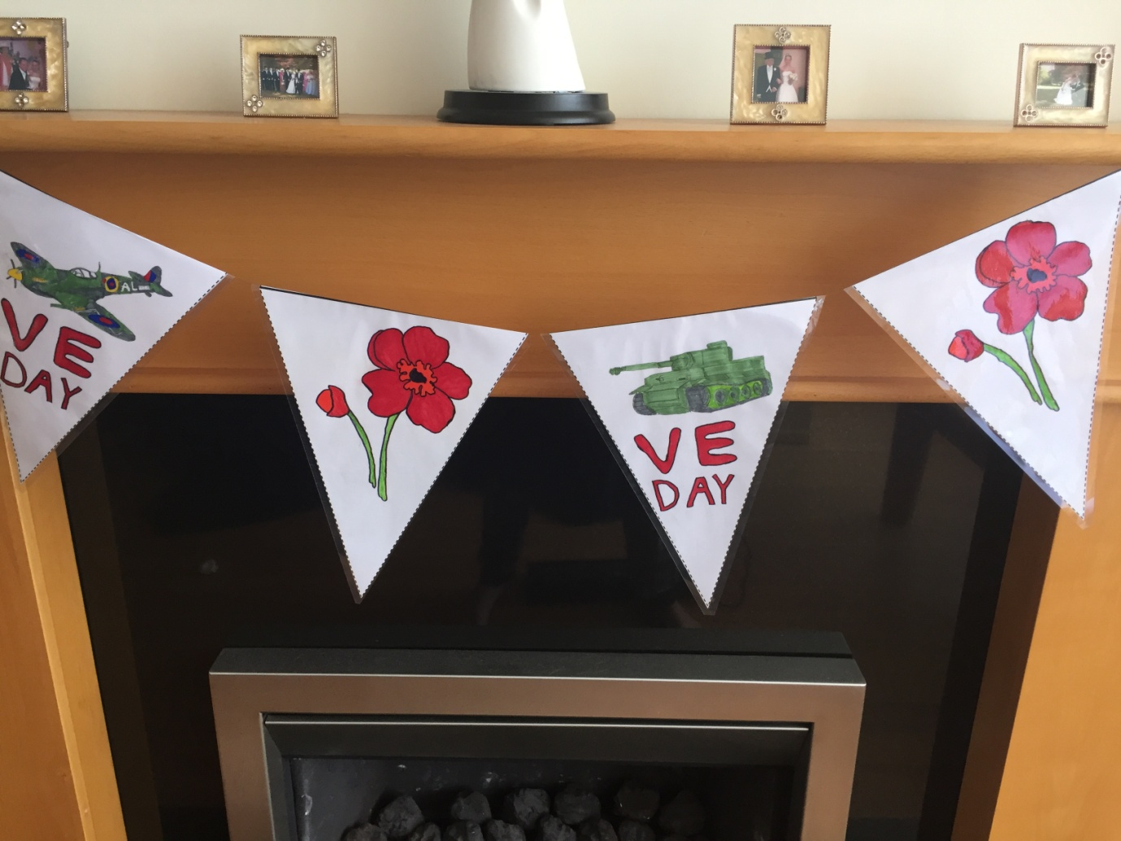
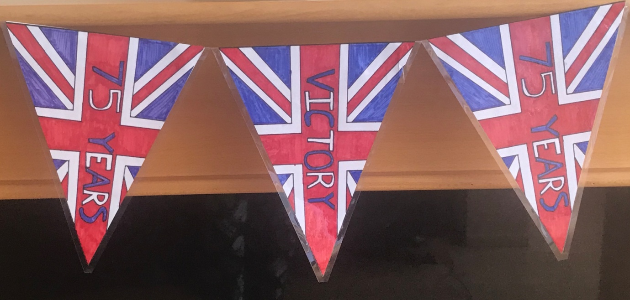
Lydia Hale
Jamie Bishop
Tristan Harvey
Rhys Harper-Smith
Kian Harper-Smith

Maths
Recently, students in 8A and 9A completed an online Maths Challenge organised by the UK Maths Trust.
We are really pleased that the following students were awarded certificates:
Joshua Peruffo - Silver and Joint Best In School
Nicholas Tolley - Silver and Joint Best In School​
Corey Gammond - Silver
Anna Fish - Silver
Hannah Murdoch - Silver
Lauren Parkinson - Silver
Mete Surucu - Silver
Naomi Watters - Silver
Yoshi Luffingham-Adams - Bronze
Holly Bunston - Bronze
Alfred Edwards - Bronze
Tristan Harvey - Bronze
Lucy-Jo Messer - Bronze
Olly Pullen - Bronze
Daniel Whittall - Bronze
Idrees Akhtar - Bronze
Eli Ashbolt - Bronze
Kitty Devereaux - Bronze
Rubyn Dimond - Bronze
Adam Little - Bronze
Jessica Prime - Bronze
Lily Spinks - Bronze

Roll call of honour:

Art
Year 8 | Year 9 | Year 10 | Year 11
Holly Bunston  Ben Connolly  Ashia Day  Esme Grice  Gethin Hanson -Green  Tristan Harvey  Yoshi Luffingham –Adams  James Moore  Tessa Morgan  Charlie Palmer  Josh Peruffo  Ellie Pilliner  Dean Price  Olly Pullen  Lily Spinks  Maggi Valbuena  Oliver Walker  Daniel Whittall  Florence Wickham  Molly Williams | Jacob Amos  Emma Cave- Browne-Cave  Lewis Davies  Logan Froggatt  Adam Little  Erin Mahon  Charles Mellor  Grace McConnachie  Millie Moruzzi  Jessica Prime  Joshua Truluck  Caitlin Watters  Naomi Watters  Ethan Wood | Joseph Cameron –Swan  Drew Carter  Matthew Cramp  Jasmyn Cross  Evie Hemming  Dylan McDonagh  Jessica Morgan  Seb Parry  Rain Peak-Morison  Hope Saunders  Blaine Slater  Tillie Williams | Anthony Andrews  George Benbow  Archie Best  Jaime Bishop  Amelia Cook  Lucy Hall  Jacob Jones  Rowan Kelly  Ellie Mason  Jack Oxenham  Ned Pullen  Joseph Richards  Leila Simner  Tazmine Smith  Joza Truelove  Grace Woodhall

Child - Development
Year 10 | Year 11
Maddie Crump  Katie Evans  Hollie Griffiths  Lucie Gummery  Natasha Holder  Sophie Hudson  Ruby Hunt  Sophie Waygood  Leah Wilde  Annie Wright | Freya Bowdler  Emilia Davies  Ella Everall  Callie Gledhill  Bobbi-lee Gurney  Emma McConnachie

Citizenship
Year 8
Megan Boardman  Ruby Buckland  Oliver Cook  Reuben D'Arcy Potts  Holly Davies  Ashia Day  Alfie Edwards  Amy Gummery  Gethin Hanson-Green | Lexi-Jean James  Kristoph Ludlow  Oliver Murray  Josh Peruffo  Cerys Pitt  Andrew Smith  Anna Teelan

Design and Technology
Year 8 | Year 9 | Year 10 | Year 11
Jack Bartley (Food & RM)  Charlie Bishop (Food & RM)  Ruby Buckland (RM)  Oliver Cook (Food)  Reuben D’arcy-Potts (Food)  Ashia Day (Food)  Kaitlyn Gore (Food)  Esme Grice (Food)  Tristan Harvey (Food)  Gethin Hanson-Green (Food)  Tessa Morgan (Food)  Charlie Palmer (Food)  Josh Peruffo (Food)  Ellie Pilliner (Food & RM)  Dean Price (Food)  Gabrielle Price (RM) | Jacob Amos (Food)  Eirian Davies (RM)  Kitty Devereaux (Food)  Rubyn Dimond (Food)  Jess Dyer (Food)  Tom Dyer (Food & RM)  Charlie Mellor (Food)  Grace McConnachie (Food & RM)  Jessica Prime (Food & RM)  Sydney Truelove (Food)  Naomi Watters (Food)  Ethan Wood (Food) | Amelie Covill (RM)  Alisha Danby (Food)  Annabel Digweed (Food)  Niav Fellows (Food)  Kian Harper Smith (RM)  Rhys Harper Smith (RM)  Joe Hussey (RM)  Jessie Morgan (Food)  Harriet Shepard-Brown (Food) | Lucy Hall (RM)  Maddie Morton (Food)  Fin Pitts (Food)  Alister Price (Food)  Amira Vieyra (RM)

Drama
Year 9 | Year 10 | Year 11
Charlie Mellor | Lucy Bentham  Oli Grice  Oscar Jones  Rain Peak Morison | Abbie Mcvarish  Harriet Tree

English
Year 8 | Year 9 | Year 10 | Year 11
Charlie Bishop  Ben Connolly  Oliver Cook  Holly Davies  Ashia Day  Esme Grice  Tristan Harvey  Lexi-Jean James  Yoshi Luffingham -Adams  Lucy-Jo Messer  Oliver Murray  Charlie Palmer  Josh Peruffo  Oliver Pullen  Annette Sims | Jacob Amos  Cain Bentley  Kitty Deveraux  Anna Fish  Logan Frogatt  Adam Little  Jack Morgan  Hannah Murdoch  Jessica Prime  Caitlin Watters  Naomi Watters  George Williams  Ethan Wood | Lucy Bentham  Joe Collyer  Amelie Covill  Annabelle Digweed  Niav Fellows  Oliver Grice  Hollie Griffiths  Imogen Harris  Natasha Holder  Sophie Hudson  Ruby Hunt  Elyssa Hunter  Dylan Jones  Oscar Jones  Rain Peak - Morison  Molly Sherrard  Sophie Thomas Watts  Tillie Williams  Annie Wright | George Benbow  Jaime Bishop  Amelia Cook  Emilia Davies  Bobbi Lee Gurney  Lucy Hall  Fynnley Johns  Ellie Mason  Jac McQuiston  Grace Murdoch  Grace Norman  Freddie Parker  Fin Pitts  Alister Price  Ned Pullen  Leila Simner  Harriet Tree  Grace Woodhall

Geography
Year 8 | Year 9 | Year 10 | Year 11
Charlie Bishop  Reuben D'arcy Potts  Holly Davies  Oli Walker | Hannah Murdoch  Naomi Watters | Amelie Covill  Lucie Gummery | Callum Baker-Jones Jaime Bishop  Lucy Hall

History
Year 8 | Year 9 | Year 10 | Year 11
Charlie Bishop  Holly Bunston  Esme Grice  Lydia Hale  Yoshi Luffingham-Adams  Tessa Morgan  James Moore  Charlie Palmer  Ellie Pilliner  Cerys Pitt  Gabby Price  Olly Pullen  Freya Sherrard  Mollie Williams | Miya Black  Emma Cave-Browne-Cave  Eirian Davies  Rubyn Dimond  Kitty Devereaux  Jess Dyer  Tom Dyer  Josh Kent  Cerys Pitt  Jessica Prime  Demi Eli-Sandiford  Anna Fish  Eli Jones  Grace McConnachie  Jack Morgan  Hannah Murdock  Frankie Richards  Evie Smith  Issy Smith  Mete Surucu  Nicholas Tolley  Sydney Truelove  Naomi Watters  Davey Williams | Kyle Barton  Lucy Bentham.  Niav Fellows  Oliver Grice  Rhys Harper Smith  Kian Harper Smith  Evie Hemming  Sophie Hudson  Elyssa Hunter  Alex Kitchen  Rain Peak Morison  Archie Pilliner  Erin Roberts  Molly Sherrard  Tillie Williams  Annie Wright  Damian Zarzycki | George Benbow  Jamie Bishop  Emilia Davies  Bobbi Lee Gurney  Charles Hale  Poppy Lewis  Elllie Mason  Grace Norman  Freddie Parker  Fin Pitts  Luke Sheppard  Leila Simner  Kelsey Watton

ICT
Year 8 | Year 9 | Year 10 | Year 11
Holly Bunston  Annette Sims  Daniel Whittall | Cerys Pitt  Jacob Amos | Elyssa Hunter  Oscar Jones  Molly Sherrard  Tillie Williams | Freddie Bufton  Andrew Cheung  Emilia Davies  Lucy Hall  Fynnley Johns  Abbi MacVarish  Ben Whittall

Maths
Year 8 | Year 9 | Year 10 | Year 11
Charlie Bishop  Tom Brethereton  Holly Bunston,  Louis Campbell Gibson  Ben Connolly  Holly Davies  Ashia Day  Kaitlyn Gore  Carla Green  Esme Grice,  Amy Gummery  Kordelia Harfield  Ethan McPherson Charlie Palmer,  Ellie Pilliner,  Cerys Pitt  Olly Pullen  Oliver Walker  Annette Simms | Emma Cave Brown Cave  Lewis Davies  Marley Davies  Ella Dawe  Kitty Devereux  Jess Dyer  Tom Dyer  Logan Froggatt  Grace McConnachie  Charlie Mellor  Jack Morgan  Hannah Murdoch  Harvey Phipps  Jess Prime  Caitlin Watters  George Wood | Kyle Barton  Lucy Bentham  Amelie Covill  Matthew Cramp  Annabel Digweed  Niav Fellows  Oliver Grice  Hollie Griffiths  Imogen Harris  Sophie Hudson  Elyssa Hunter  Dylan Jones  Fergus McQuiston  Jack Miller  Jessica Morgan  Rain Peak Morison  Molly Sherrard  Blaine Slater  Faith Webb,  Tillie Williams  Annie Wright | Callum Baker Jones  Jaime Bishop  Freddie Bufton  Amelia Cook,  Emilia Davies  Iestyn Davies  Bobbi Gurney  Lucy Hall  Fynn Johns  Ellie Mason  Emma McConnachie  Jac McQuiston  Grace Murdoch  Grace Norman  Ellie Peden  Martha Pilliner  Alister Price  Ned Pullen  Leila Simner  Hattie Tree

Modern Foreign Languages
Year 8 | Year 9 | Year 10 | Year 11
Aliyah Akhtar  Jack Bartley  Charlie Bishop  Megan Boardman  Tom Bretherton  Holly Bunston  Ben Connolly  Oli Cook  Reuben D'Arcy-Potts  Holly Davies  Ashia Day  Alfie Edwards  Kaitlyn Gore  Carla Green  Esme Grice  Tristan Harvey  Kris Ludlow  Ethan MacPherson  Katie McGory Taplin  Lucy-Jo Messer  James Moore  Oliver Murray  Sophia North  Charlie Palmer  Josh Peruffo  Ellie Pilliner  Cerys Pitt  Dean Price  Layla Price  Olly Pullen  Daniel Sherrard  Freya Sherrard  Anette Sims  Anna Teelan  Maggie Valbuena  Oliver walker  Emily Wheeler-Jones  Daniel Whittall  Mollie Williams | Jacob Amos  Eli Ashbolt  Eirian Davies  Marley Davies  Kitty Devereaux  Rubyn Dimond  Jess Dyer  Tom Dyer  Inca Fersey Perkins  Evie Holder –Jones  Anya Hughes  Eli Jones  Josh Kent  Arley Martin  Grace McCoanchie  Jack Morgan  Milly Moruzzi  Hannah Murdoch  Jessica Prime  Isabelle Rawlings  Frankie Richards  Evie Smith  Naomi Watters  George Williams  Ethan Wood | Lucy Bentham  Amelie Covill  Katie Evans  Niav Fellows  Ollie Grice  Hollie Griffiths  Lucie Gummery  Imogen Harris  Sophie Hudson  Ruby Hunt  Elyssa Hunter  Rain Peak – Morison  Molly Sherrard  Blaine Slater  Tillie Williams  Annie Wright | Jamie Bishop  George Benbow  Andrew Cheung  Emilia Davies  Jack Davies  Bobbi Lee Gurney  Fynnley Johns  Alistair Price  Ellie Mason  Maddie Moreton  Grace Murdoch  Martha Pilliner  Ned Pullen  Harriet Tree  Joza Truelove​  Grace Woodhall

Music
Year 8 | Year 9 | Year 10 | Year 11
Charlie Bishop  Charlie Boxall  Holly Davies  Ashia Day  Alfred Edwards  Amy Gummery  Kordellia Harfield  Lexi-Jean James  Katie McGory Taplin  Joshua Peruffo  Olly Pullen  Daniel Sherrard &  Evie Skinner  Andrew Smith  Dan Whittall | Jacob Amos  Carys Brigg  Luke Brookes  Isobel Arundel,  Eirian Davies  Lewis Davies  Jessica Dyer  Tom Dyer  Anya Hughes  Adam Little  Grace McConnachie  Millie Moruzzi  Charlie Mellor  Harvey Phipps  Jessica Prime  Madison Reynolds  George Williams  Ethan Wood  George Wood | Amelie Covill  Elyssa Hunter,  Oscar Jones,  Fergus McQuiston  Rain Peak-Morison  Molly Sherrard  Sophie Thomas Watts | Freya Bowdler  Ellie Mason  Ned Pullen

P:E
Year 10 | Year 11
James Atkinson  Lucy Bentham  Maddie Crump  Annabel Digweed  Katie Evans  Niav Fellows  Ali Fish  Hollie Griffiths  Lucie Gummery  Natasha Holder  Sophie Hudson  Joe Hussey  Alex Kitchen  Mollie Lewis  Fergus McQuiston  Jessie Morgan  Jack Palmer  Joe Pennington  Rudy Pugh  Blaine Slater  Ashleigh Smith  Sophie Waygood  Leah Wilde  George Williams | Georgina Blain  Freddie Bufton  Kieryn Diamond  Kaden Fish  Bobbi Gurney  Owen Lloyd  Jac Mcquiston  Grace Murdoch  Freddie Parker  Clara Price  Martha Pilliner  Harriet Tree  Ben Whittall  Grace Woodall  ​

R:E
Year 8 | Year 9 | Year 10 | Year 11
Ashia Day  Alfred Edwards  Amy Gummery  Josh Peruffo | Isobel Arundale  Josh Kent  Grace McConnachie  Maddie Reynolds  Toby Stowell  Sydney Truelove  Davey WIlliams  George Williams | Lucy Bentham  Niav Fellows  Alistair Fish  Lucie Gummery  Imogen Harris  Sophie Hudson  Elyssa Hunter  Rain Peak Morison  Molly Sherrard  Tillie Williams  ​ | Jamie Bishop  Amelia Cook  Andrew Cheung  Emilia Davies  Lucy Hall  Fynnley Johns  Abbi Macvarish  Jac McQuiston  Grace Murdoch  Ned Pullen  Alister Price  Amira Vieyra  Harriet Tree​  Grace Woodhall

Science
Year 8 | Year 9 | Year 10 | Year 11
Megan Boardman  Ashia Day  Olly Pullen | Charles Mellor | Lucy Bentham  Elyssa Hunter  Molly Sherrard  Emilie Thursfield  Tillie Williams | Grace Murdoch  Alister Price  Harriet Tree

