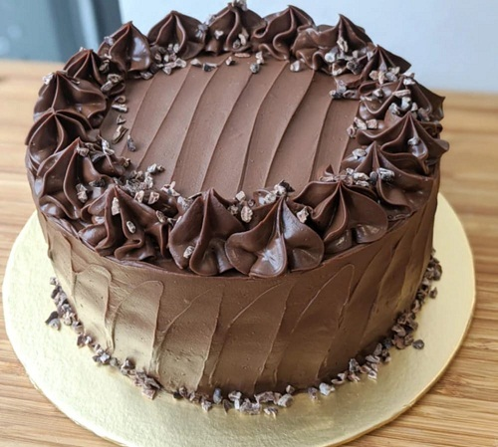
Celebration Cake
Week 1
200g soft margarine- get from school
200g caster sugar
200g self-raising flour-get from school
4 eggs
For Chocolate:
Take out 50g flour and add 50g cocoa powder
Method:
- Preheat the oven to 180⁰C/Gas 4.
- Grease and Line Cake tin
- Cream together the butter and sugar using a wooden spoon. The mixture should look light and fluffy.
- In a small bowl, beat the eggs with a fork. Gradually add to the mixture, a little at a time.
- Sieve the flour and cocoa powder (if using). Fold in to the mixture.
- Divide the mixture between the cake tins and bake for 25-30 minutes. They should spring back when lightly pressed.
- Remove from tins and place on a wire cooling rack.

Week 2 Cake decorations:
Butter icing (whole cake)
400g icing sugar
200g butter
Few drops of vanilla extract-get from school
(Add two tablespoons cocoa powder for chocolate)
Decorations of your choice (planned in the previous week)
